EPOS Releases Compact 4K USB Webcam

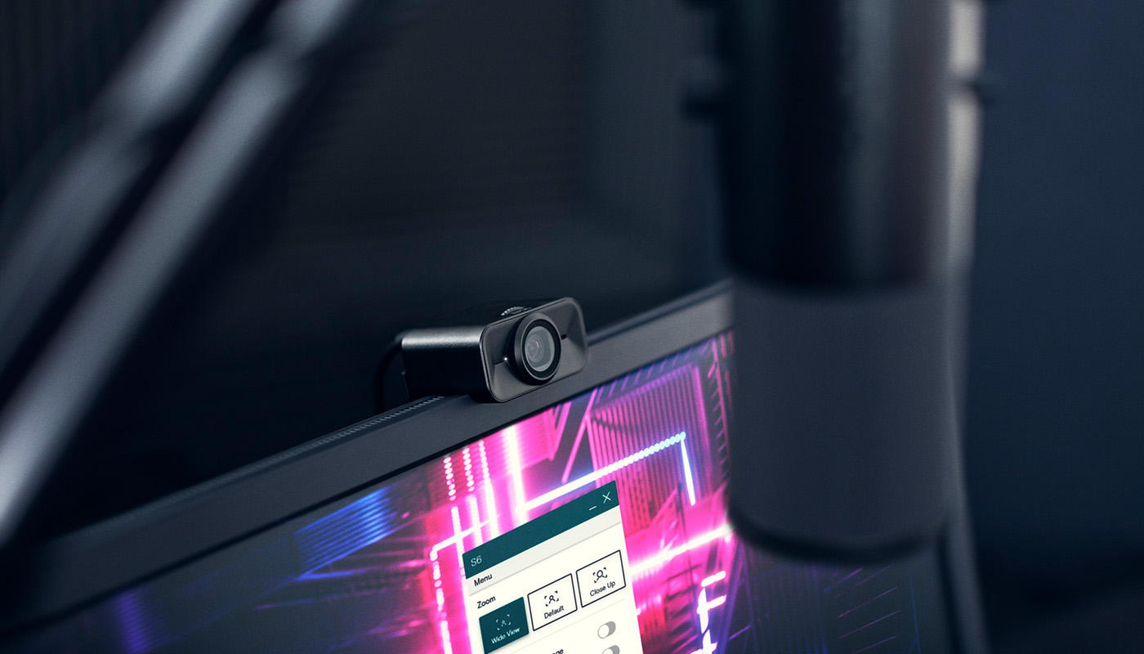

The S6 webcam delivers sharp 4K resolution and features integrated microphones with digital noise cancellation, and personal customization preferences

Copenhagen, Denmark – March 7, 2023 – Expert gaming audio brand EPOS is now offering a first-class video solution alongside its expansive audio lineup, via its latest product, the S6 4K USB Webcam.

Designed for content creation, this webcam incorporates premium features such as 4K resolution for recording, full HD streaming, dual microphones with digital noise cancellation and personalization possibilities. The webcam’s light and compact design makes it easy to carry around for use whenever inspiration strikes, and its mounting features make securing the webcam on a screen or tripod intuitive.

The S6 comes as plug and play straight from the box and works perfectly with both PC and Mac, optimized for popular streaming software such as OBS (Open Broadcast Software) and Streamlabs. The compatibility makes it a versatile product as it also works with EPOS Connect software allowing for quick and easy further customization such as zoom, light settings, contrast and saturation ​per the user’s preference.

The S6 comes with Microsoft Teams and Zoom certifications.

Ultra-Sharp Video and Audio Quality
The S6 webcam delivers a vivid 4K resolution to display stunning, crisp video that will keep audiences entertained. The automatic light sensor balances brightness in real-time and adapts with changes in lighting and scenery which makes its full HD resolution for streaming stand out even more. Additionally, the webcam includes two integrated microphones with digital noise cancellation, eliminating background noise and ensuring clear voice pick-up even in noisy environments.

Functional Design
The S6 is a robust webcam with an elegant and slick aluminum housing design with a total weight of only 80 grams. A portable carrying case is also included, giving the lightweight S6 superior mobility on-the-go. It features an LED light indicator, scratch-protected glass lens, and a built-in privacy shutter. Connecting the webcam is made simple by using the provided USB-C or USB-A cables.

Price and Availability
The S6 is available on the official EPOS website and from select retailers at a suggested retail price of $/€ 199 USD/EUR.

About EPOS
EPOS designs, manufactures, and sells high-end audio and video solutions for gamers and business professionals around the world.

Based on decades of psychoacoustic research, EPOS designs audio gaming solutions with unique algorithms and acoustics that provide the best conditions for the brain, enabling gamers to react faster, communicate better and experience full immersion.

Owned by the world-leading hearing healthcare and audio technology group, Demant, and with headquarters in Copenhagen, Denmark, EPOS builds on more than 115 years’ audio expertise and operates in a global market with offices and partners in more than 60 countries.

Find more information at www.eposaudio.com

###

Global PR Contact
Monica Liv Neerdal
moee@eposaudio.com

